**123 Switch**

**Black = positive integers,**

**Red = negative integers**

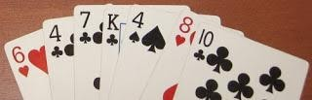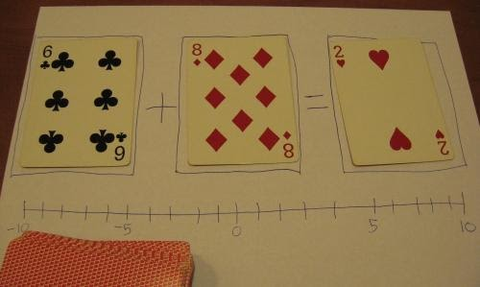

You'll need: a deck of cards for each group of 2-4 players, the DIY graphic organizer seen above, and paper for each student to write down (and double check) every simple number sentence that's created.

**Black cards represent positive integers and red cards represent negatives**.  **Aces are ones** and all other **face cards are tens**.

1. Each player gets 7 cards.  The remaining cards are a draw pile.
2. For the first turn, the player must **create a correct number sentence in the form A + B = C** (for example, 6 + (-8) = -2, as in the photo above)
3. For all subsequent turns, players can **replace one, two or all three cards to create a correct number sentence**.  They should stack the cards on top of each other (so there's always three showing).
4. As in *Uno*, **each player must put down at least one card per turn**.  If they can't do so with the cards in their hand, they have to draw cards until they can put down something.
5. The objective is to **be the first player to get rid of all of your cards**.

Let's say it's my turn to continue the example above, and my hand is the one on the left.  I would have the option of playing one, two or three cards:  
  
**One card:** Replace just the -8 with my own -8.  
  
**Two cards:** Replace the 6 and -8 with -6 and 4, which still equals -2.  I could also leave the 6, replace the -8 with 4, and the -2 with 10 (6 + 4 = 10).  
  
**Three cards:** I could replace all three cards with -6 + 10 = 4  
  
As they play, **students should write down every number sentence** that's made, and should be encouraged to **watch each other closely** (with your help, of course).  Every group will have had different practice, and can proceed at their own speed.  That would make this quality independent practice for your lesson on this concept.   
  
Adaptations

1. **Designate a wild card.**  I'd leave aces as ones and use one of the other face cards.
2. **Assign other values to face cards.**  Jack=11, Queen=12, King=13
3. **Change the game to subtraction.**  This adds a significant layer of difficulty (as I found out when testing   this idea out) and could make each game much longer.
4. **Give each player more cards.**  I tested this out and estimate that one game should take about 5-10 minutes using the default 7 cards.  I don't recommend using less cards, since it reduces the practice your kids would get, but you could give each player 10 cards instead.
5. **If you run out of cards in the draw pile,** take all of the stacked cards except the top ones.  Shuffle them and put them in a draw pile.